
Program and Branch Name: BTech CSE-AI
PBL Progress Report – I / II / Final
Field | Details
Course Name | B. Tech CSE-AI
Course Code | CCSE0355
Faculty Name | Ms Shweta Singh
Assignment Type | Group Assignment
Student(s) Name | Devvrat Tripathi, Manas Srivastava, Pranjal Sharma, Hardik Kumar, Mritunjay Gupta
Student(s) Roll No. | 0251CSAI231, 0251CSAI144, 0251CSAI141, 0251CSAI195, 0251CSAI132
Team/Group No. (Group/Capstone only) | Group 24
Problem Statement / Project Title | Intelligent Medical Inventory Tracking System
SDG(s) | SDG 3 - Good Health & Well-being
Reporting Month | Month 1
Date of Submission | 07-09-2026

Student Declaration
I/We certify that this assignment is my/our own work, with all sources appropriately acknowledged. I/We understand that a 0% mark and further academic penalties may apply if the content is found to be plagiarised or inappropriately AI-generated.
Student Name & Signature(s): Devvrat Tripathi 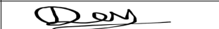 Manas Srivastava 
Pranjal Sharma  Hardik Kumar 
Mritunjay Gupta 
Date: 07-09-26

PBL Progress Report – I

Review 1: Problem Understanding & Initial Progress
Review Coverage:
- Group Assignment: Unit/Module 1 and Unit/Module 2
- Capstone Project: Rubric Categories 1 and 2

Field | Details
1. Problem Statement / Assignment or Project Title | Intelligent Medical Inventory Tracking System
2. Problem Context & Background | As we all know hospitals and pharmacies often face issues like medicine stockouts, expiry mismanagement, and manual tracking errors. This project builds a Java OOP based system to track medical inventory, manage stock levels, and generate alerts for low or expired medicines.
3. Problem Identification / Understanding | Manual inventory tracking in hospitals is slow and error prone. Using Java OOP concepts like classes, inheritance, polymorphism, exception handling, and collections, we can build a efficient medical inventory management system.
4. Objectives | 1. Design a Java OOP based medical inventory system.  2. Apply inheritance and polymorphism for medicine categories.  3. Use Collections (HashMap, ArrayList) for efficient data management.  4. Implement exception handling for stock errors.  5. Support SDG 3 i.e. Good Health and Well being.
5. Target Users / Stakeholders | Primary - Hospital pharmacists and store managers.  Secondary - Hospital administrators and doctors.
6. Research / Literature Review Completed | 1. Studied Java OOP concepts: classes, objects, inheritance, polymorphism.  2. Explored Java Collections Framework (HashMap, ArrayList).  3. Read a research paper on OOP based hospital management systems.
7. Unit/Module Concepts Identified for Application | Unit 1 - OOP Basics: Classes, objects, constructors, encapsulation applied to medicine and inventory classes.  Unit 2 - Inheritance & Polymorphism: Medicine category hierarchy using inheritance; method overriding for different stock types.  Unit 3 - Exception Handling: Custom exceptions for stockout and expiry alerts.
8. Work Completed During Month 1 | i. Submitted topic approval form.  ii. Studied OOP concepts (Unit 1, 2, 3).  iii. Designed class diagram for inventory system.  iv. Set up Java development environment (IntelliJ/Eclipse).
9. Evidence / Supporting Material | i. System architecture diagram (see below).  ii. GitHub repository created.  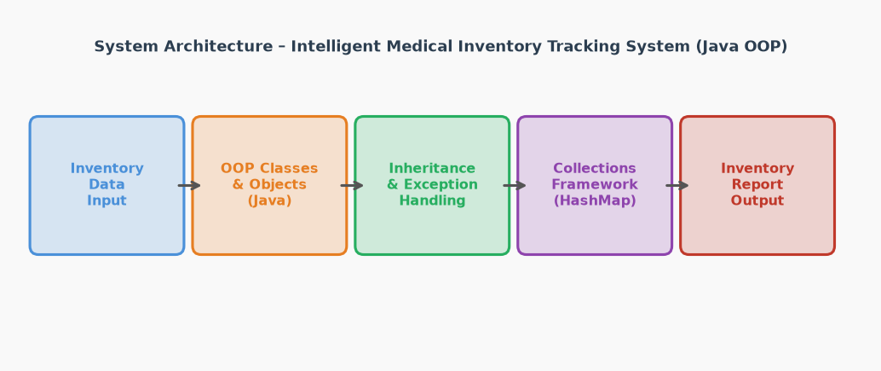
10. Challenges Faced | i. Designing a clean class hierarchy for different medicine types.  ii. Managing concurrent stock updates.  iii. Handling edge cases like expired stock and zero quantity.
11. Individual / Team Contribution | Devvrat Tripathi (Team Lead): Project coordination, architecture design.  Manas Srivastava (Researcher): Literature review, requirement gathering.  Pranjal Sharma (Report): Documentation and formatting.  Hardik Kumar (Facilitator): Environment setup, tool integration.  Mritunjay Gupta (Researcher): Class design, feature exploration.
12. Overall Progress (%) | 25%
13. Plan for Next Review | i. Implement Collections Framework for inventory storage (Unit 4).  ii. Add multithreading for concurrent stock updates (Unit 5).  iii. Begin GUI design for the system interface.  iv. Start unit testing and validation.

Faculty Evaluation:
- To be completed by Faculty in Moodle

